Project Planning Phase

**Project Planning Template (Product Backlog, Sprint Planning, Stories, Story points)**

|  |  |
| --- | --- |
| Date | 3 November 2022 |
| Team ID | PNT2022TMID43624 |
| Project Name | Plasma Donor Application |
| Maximum Marks | 8 Marks |

Product Backlog, Sprint Schedule, and Estimation (4 Marks)

|  |  |  |  |  |  |  |
| --- | --- | --- | --- | --- | --- | --- |
| **Sprint** | **Functional**  **Requirement (Epic)** | **User Story Number** | **User Story / Task** | **Story Points** | **Priority** | **Team Members** |
| Sprint-1 | Registration | USN-1 | A user can register for the application by entering their email, password, and confirming the password. | 3 | High | * Rajasubhiksha * Malavika * Varun |
| Email verification | USN-2 | A user will receive confirmation email once they have registered for the application. | 3 | High | * Vishnu * Malavika * Rajasubhiksha |
| Login | USN-3 | A user can log in and enter the application by proceeding with email & password. | 2 | High | * Vishnu * Varun |
| Donor/Recipient Profile | USN-4 | A user is able to register themselves as verified plasma donor or a recipient. | 3 | High | * Varun * Malavika |
| Sprint-2 | Virtual Certificate | USN-5 | A user will get a virtual donation certificate after a verified successful Plasma donation. | 2 | Medium | * Rajasubhiksha * Vishnu |

|  |  |  |  |  |  |  |
| --- | --- | --- | --- | --- | --- | --- |
| **Sprint** | **Functional**  **Requirement (Epic)** | **User Story Number** | **User Story / Task** | **Story Points** | **Priority** | **Team Members** |
|  | Plasma Request | USN-6 | A verified clinic can make a Plasma request through the application. | 3 | High | * Malavika * Varun * Rajasubiksha |
| Verification of Donor’s details | USN-7 | We the administrators will verify the details provided by the donor/ recipient are correct for a genuine Plasma donation or plasma recipient. | 2 | Medium | * Vishnu * Rajasubhiksha * Varun |
| Sprint-3 | Accept the donation request | USN-8 | A user and a registered donor will get a notification to accept the plasma request for their specific blood type. | 3 | High | * Malavika * Rajasubhiksha |
| Communication Channel | USN-9 | A patient is able to communicate with the donor personally within the application. | 3 | Medium | * Varun * Vishnu |
| Share  Location | USN-10 | A user and a registered donor is able to share their location with the  recipient after accepting their Plasma request. | 3 | Medium | * Malavika * Varun * Rajasubhiksha |
| Administrator | USN-11 | An admin will store the registered donors and recipients details after their verification into the database. | 3 | High | * Vishnu * Varun * Rajasubhiksha |
| Sprint-4 | Support | USN-12 | A user is able to ask basic question  related to plasma donation/ Plasma recipient with the help of chat-bot. | 2 | Medium | * Vishnu * Malavika |

|  |  |  |  |  |  |  |
| --- | --- | --- | --- | --- | --- | --- |
| **Sprint** | **Functional**  **Requirement (Epic)** | **User Story Number** | **User Story / Task** | **Story Points** | **Priority** | **Team Members** |
|  | About | USN-13 | A new user can use the About page to know information and details related to Plasma donation and benefits. Also the details of Plasma. | 2 | Medium | * Rajasubiksha * varun * Malavika |
| Administrator | USN-14 | An admin will approve all the Plasma transaction in the application after every proper verification and will update the Plasma availability and donors count periodically. | 3 | High | * Varun * Malavika * Vishnu |

Project Tracker, Velocity & Burndown Chart: (4 Marks)

|  |  |  |  |  |  |  |
| --- | --- | --- | --- | --- | --- | --- |
| **Sprint** | **Total Story Points** | **Duration** | **Sprint Start Date** | **Sprint End Date (Planned)** | **Story Points Completed (as on Planned End Date)** | **Sprint Release Date (Actual)** |
| Sprint-1 | 20 | 6 Days | 24 Oct 2022 | 29 Oct 2022 | 18 | 03 Nov 2022 |
| Sprint-2 | 20 | 6 Days | 31 Oct 2022 | 05 Nov 2022 | 20 | 09 Nov 2022 |
| Sprint-3 | 20 | 6 Days | 07 Nov 2022 | 12 Nov 2022 | 18 | 15 Nov 2022 |
| Sprint-4 | 20 | 6 Days | 14 Nov 2022 | 19 Nov 2022 | 18 | 21 Nov 2022 |

Velocity:

Imagine we have a 10-day sprint duration, and the velocity of the team is 20 (points per sprint). Let’s calculate the team’s average velocity (AV) per iteration unit (story points per day)

Total number of days = sprint 1 + sprint 2 + sprint 3 + sprint 4 = 6 + 6 + 6 + 6 = 24

Total number of story points = 18 + 20 + 18 + 18 = 74

Average velocity per sprint = 74 / 24

~= 3.083333

= 3

Burndown Chart:

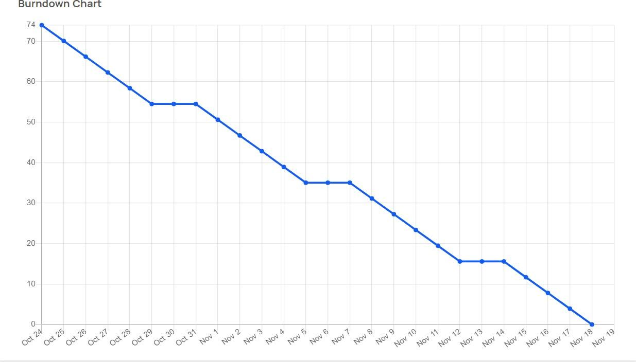

Estimated Burndown Chart